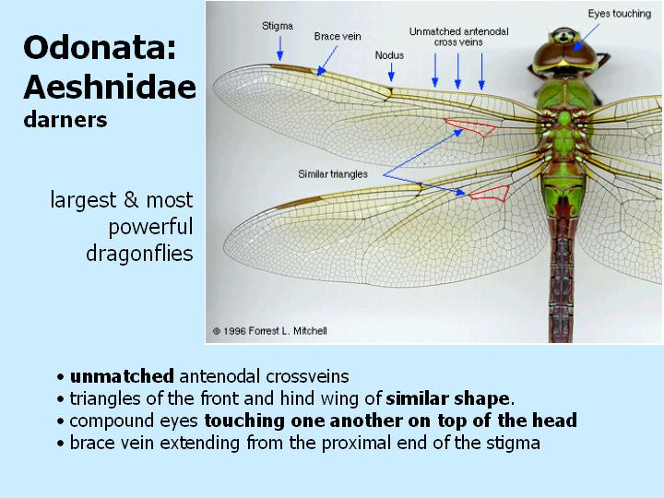

**Lestidae – spread-wing**

**Aeschnidae – darners**

1. Families in Odonata – dragon/damselflies

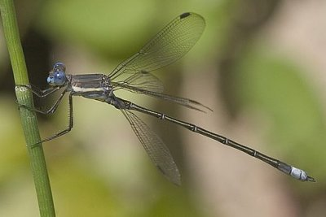

**Coenagionidae – narrow-winged**

**Gomphidae - clubtails**

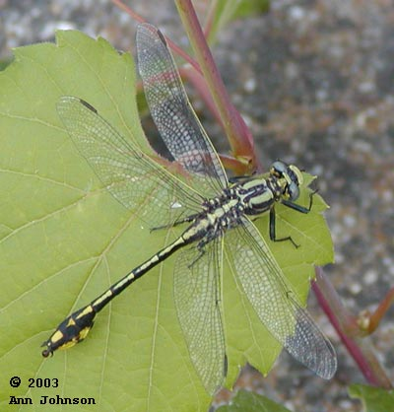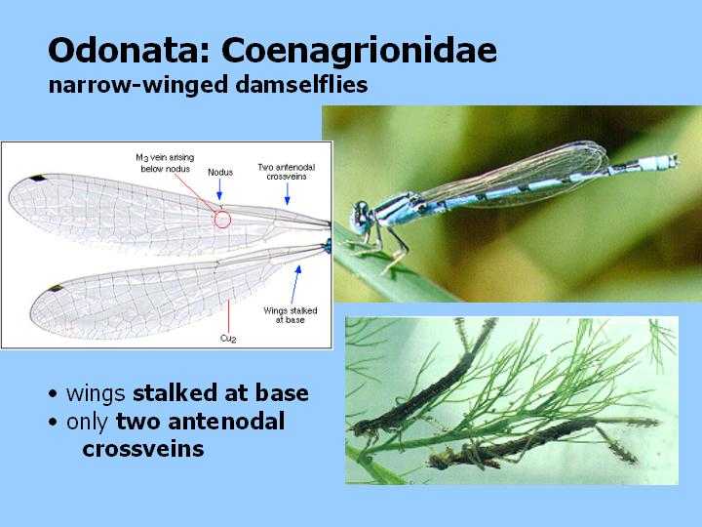

**Libellulidae – skimmers**

